**EXTENDED PROJECT QUALIFICATION**

**EPQ 2022**

**EPQ title: What is brain computer interface?**

**By Marim Sabah**

Table of contents

**Abstract**

**Introduction**

**Literature review**

Working principle of BCI system

Signal acquisition

Pre-processing

Feature extraction

Classification

Control interface

Types of BCI

Invasive

Semi-invasive

ECoG based BCI

Non-invasive

EGG based BCI

How does BCI help with paralyzed people?

History of BCI

Future of BCI

Ethics

**Conclusion**

**Bibliography**

Abstract

Brain-computer interface (BCI) is a technology that uses brain or nervous system data to control computers, machines, and external devices. The end result is to be able to control devices just by our simple thoughts from our brain signals being transferred to the certain machine we want to use. It was originally made to help in the medical area for people with limited mobility, [1] more specifically people who are paralysed by neurological neuromuscular disorders, such as amyotrophic lateral sclerosis, brain stem stroke, or spinal cord faults. In this review we will look at how brain computer interface works, the different steps that form a standard BCI (signal acquisition, preprocessing or signal enhancement, feature extraction, classification, and the control interface) [2]. I will be describing the different types of BCI: non-invasive, semi-invasive and invasive. I will also discuss EEg and ECoG based BCi as well as their benefits and drawbacks. [4] My next discussion will be clinic BCI trials, including a trail in how BCI helped a paralyzed women move devices with just her brain signals. Then the history and future of BCI.

Introduction

Brain computer interface (BCI) is a hardware and software communications system that enables humans to interact with their surroundings, without the involvement of peripheral nerves and muscles, by using control signals generated from electroencephalographic parts. [2] Its commonly split into three types: non-invasive the sensors are placed on the scalp to measure the electrical potentials produced by the brain (EEG) or the magnetic field (MEG); semi- invasive where electrodes are placed on the exposed surface of the brain (ECoG) and invasive where the micro-electrodes are placed directly into the cortex, measuring the activity of a single neurone. [4] There are different steps that form a standard BCI which are signal acquisition, pre-processing, feature extraction, classification and the control interface [2]. The signal acquisition stage would capture and measure brain signals using a sensor modality, and then they may also perform noise reduction to remove electrical noise and other unnecessary signal characteristics when amplifying the signal levels.[3] This allows the signals to be transmitted to a computer once digitized so they can be analysed. [4] Then for further processing, the signals need to be prepared in a suitable form which is what pre-processing is for. The feature extraction stage identifies the different information in the brain signals that have been recorded by analysing digitally and filters out irrelevant signals, so we can distinguish the signal features related to the person's intent. [4] This is a challenging task as brain signals are mixed with other signals coming from a finite set of brain activities that overlap in both time and space. [6] We then have classification which uses feature vectors that have been extracted from brain signals to recognize the user’s intention. [12] The device operation then provides feedback to the user finally which would complete the loop of BCI, e.g. cursor control, letter selection, robotic arm operation.[11]

Working principle of BCI system

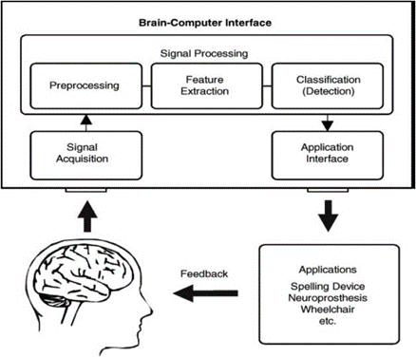

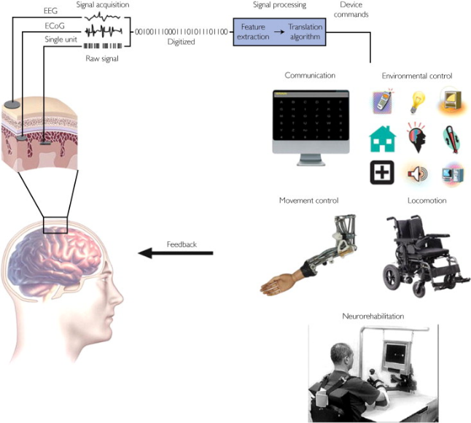

*Both diagrams of the cycle of bci.*

***Signal acquisition***

Signal acquisition is capturing and measuring brain signals [3] using a particular sensor modality (for example measuring metabolic activity with fMRI). The sensor is basically a device implanted in the brain usually multi-electrode arrays that records the signals directly related to the movement. [11] The signals are then amplified to levels suitable for electronic processing [10] they may also perform noise reduction to remove electrical noise and other unnecessary signal characteristics. [3] The signals are then digitized and transmitted to a computer. [10]

***Pre-processing***

Pre-processing has to happen first before processing happens to prepare the signals which would remove the effects that would make the signals too large, too little or fractured. [12] The routines prepare the data for analysis. It includes classifying the data into one of these three kinds and processing accordingly to provide the best output. This is why processes like data filtering, data ordering, data editing and noise modelling [8] are involved in any data pre-processing and is very important. Overall, it eliminates variations that arise during the acquisition of an image without evading essential information. [9]

***Feature extraction***

During Feature extraction, features are extracted from the signals in either time domain or frequency domain. [6] The main aim is to minimize the number of features while maximising the performance of classification, and this is done by analyzing the digital signals to distinguish signal characteristics and represent them in a compact form suitable for translation into output commands. These features been extracted should have good correlations with the users intent. [11]

***Classification***

This uses feature vectors that have been extracted from brain signals to recognize the user’s intention, now mostly clean from artefacts, classification algorithms are applied. We can now train a classifier to recognize which feature belongs to which class, helping figure out which mental task wants to be performed. [4]

***Control interface***

The commands from the feature translation algorithm operate the external device of the Brain Computer Interface (BCI), providing functions such as cursor control, letter selection, robotic arm operation etc. The device operation then provides feedback to the user finally, thus completing the closed loop of Brain Computer Interface(BCI). [4]

Types of BCI

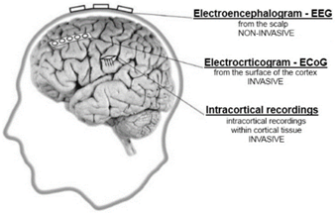

**Invasive BCI**

An invasive brain-computer interface involves the surgical implantation of a device into the skull of the user. [3] They are implanted directly into the brain during a neurosurgery and there are single unit BCIs, which detect the signal from a single area of brain cells, and multiunit BCIs which detect from multiple areas.

The benefits are that invasive BCI produces the highest quality signals since the electrodes lie on the brain cells.

The drawbacks is that they are prone to scar tissue build-up, causing the signal to become weaker, as the body reacts to a foreign object (electrodes) in the brain. [4]

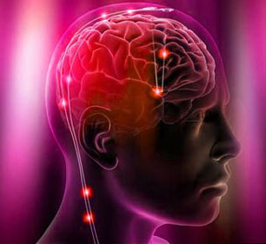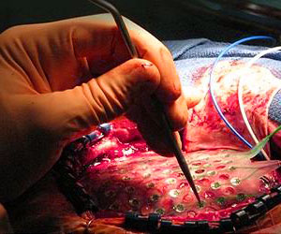

Invasive implantation of electrodes

**Semi-invasive BCI**

This is when electrodes are placed just on the exposed surface of the brain (placed inside the skill but outside the brain). A common use being electrocorticography (ECoG) which measures electrical activity from the cerebral cortex. [15] They produce better resolution signals than non-invasive BCIs and have a lower risk of forming scar-tissue in the brain than fully invasive BCIs.

***ECoG***

A form of semi-invasive BCI, the electrodes are placed on the surface of the brain, and because of this, the spatial resolution of the measured signal are better than for example EEG. The signals are recorded from the cortical surface, which is why it needs an implantation of a subdural or epidural electrode array. [5]

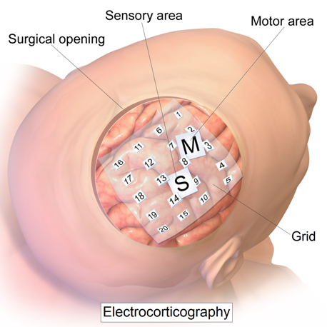

The benefits are it has high spatial resolution since the signal doesn’t have to travel to reach the scalp (it’s tenths millimeters). It also has resistance to noise since it’s not impacted by noise and artifacts like (for example) ones caused by eye movements. It’s also safer than insave BCi since the electrodes don’t penetrate into the cortex. [4]

The drawbacks are that recording brain signals is limited to the surgical opening area. It’s also limited to the surgery places and can’t be used outside it.

**Non-invasive BCI**

This is any technology that allows for brain-to-computer stimulation without needing to penetrate the skull. for brain-to-computer, it mainly uses electrodes that are specifically placed onto certain areas of the scalp in order to record brain activity. [14]

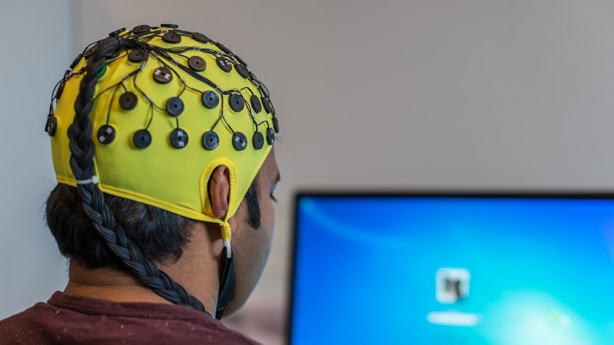

***EEG***

EEG is the recording of electrical activity through the scalp due to stimulating some of the neurons in the brain. When stimulating, lower voltages form at the synapses of a neuron and higher voltage form at the axon.

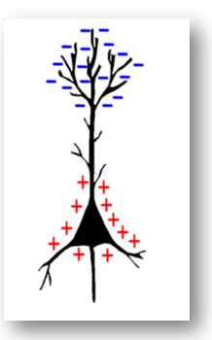

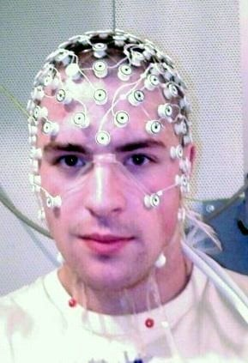

With the voltage changes that are caused by ionic currents within the nuerons being measured, these neurons are stimulated together which therefore provides enough signal to measure from the scalp. [4] These electrical activities are recorded over a short period of time through multiple electrodes located on the scalp directly on the cortex. EEG is considered as the most common method for brain signal recording because it has high temporal resolution, easy to use, safe, and affordable. [5]

To get better recordings, scientists place the electrodes accurately by following the 10-20 System. [7]

10-20 refers to specific anatomic landmarks or inter-electrode distance, such that it is 10% to 20% of the front-to-back or right- to-left head perimeters.

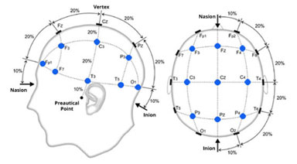

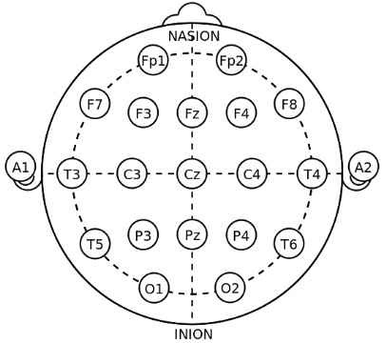

*The electrode placements of the 10-20 system.*

The benefits are that it’s non-invasive so it doesn’t need surgical implantation, which also means it ca be used outside the surgery room. [4]

The drawbacks are that electrodes outside of the skull can detect very few electric signals from the brain, so it might not be efficient. It also has lower spatial resolution, with it only being centimetres.[4]

How does BCI help with paralyzed people?

In figure 5, researchers implanted a tiny electrode chip as small as a baby aspirin into the brain of a patient with a neurological disease, who suffered a stroke in her brain stem that left her in a “locked-in” state. [15] This meant all connections to the muscles below had been severed, leaving her paralyzed and unable to speak. The chip had been placed on motor cortex which is an area within the cerebral cortex of the brain that is involved in the planning, control, and execution of voluntary movements. [5] Doing this allows the chip to detect the signals generated from the person thinking a certain thought, for example in this scenario it would be the patient thinking about moving her arm. A computer would read these signals, interpret them and send specific messages to applications. [15] So, movement signals would be sent to the robotic arm. By using BCI, it allowed the patient to just by using her thoughts- gain mobility in being able to have a drink all on her for the first time in 14 years (figure 5) [10] However, not with this patient, there are still effects in the brain due to viral attacks, requiring excessive training for proper usage, high cost, slow speed, lack of better sensor modality, invasive BCIs are risky since it requires neurosurgery etc.[11] So developments in helping in the medical area are still improving.

History of BCI

Even though brain computer interface has only just become known in the last few centuries, the start of it dates back to the 19th century, when Richard Caton [18], an English physicist, recorded the first ever animals’ electrical signals and published his results in 1875 in the British Medical Journal. [9] Discovery of the electroencephalography was a move to the development of BCI systems which was first recorded by Hans Berger in 1924. [16] In 1998 Philip Kennedy implanted the first invasive BCI into human, and in 2004 Matt Nagle (1980–2007) was the first patient with implanted invasive BCI system, who had 3rd category quadriplegia with retained speaking ability. The 2000s brought a highly increased number of studies about the BCI systems [17]. In 2006 Leuthardt et al. proved ECoG to be an effective source for control signal in BCI Systems, achieving accuracy between 73% and 100% [18] already when technology wasn’t even at its peak. In 2010 around 220,000 people with a loss of hearing already had cochlear implants implanted as the neuroprosthetic device that aims to restore hearing.[16] And two years later there was two ground-breaking studies that showed how much BCI can do and its importance. Both studies showed how the BCI systems enabled neural arm control and arm movements restoration after paralysis [18] and the first one was carried out on monkeys [18] and the second was inspired by this and done on two humans. The first study the overall success rate for both animals using the neuroprosthesis was about 80%. The second study was on a 58-year-old female and 66 years old male, who were paralysed due to a stroke. Both were able to move robotic arms, so the applied BCI system restored partially their hand motor ability increasing their quality of life. [18] There are also creations such as an ‘ultrahigh bandwidth brain-machine interfaces to connect humans and computers’ founded by Elon Musk and others, as well as working on wearable devices to allow people to text just by thinking. Which would significantly help disabled people. [18]

Future of BCI

I think without even looking at how brain-computer interface is, we can see dating back to 2006 when technology wasn’t close to what it was now, for the accuracy to be above 70% in BCI is outstanding.[8] So simply imagine what now can be invented and be brought to such a degree in success, BCI is constantly developing with already creations being made to help paralyzed people walk move devices, helping people with speech impairments and people with hearing impairments.

It’s seen by scientists and research workers that as technology improves over the years, they’ll be able to bring out a more wide variety of BCI applications useful for society. Just like it’s shown in figure 4, BCI can also restore and augment human functions thereby improving the quality of living, like improving the accuracy of brain implants.[11] It can also provide jobs for disabled people that people would think to be impossible, like flying an aeroplane just by thinking and a blind driving a vehicle. In the medical sector, research workers are working on more precise equipment and the start of wireless BCI, with the possibility of being able to replace the robotic devices and directly bypass the signals to the nerves in the damaged part of the brain, thereby allowing the paralyzed patient to move their body completely. [11] As shown, it can be a big help to improving the quality of life.

Ethics

As much as the idea of brain-computer interface is useful and can help society, there are a few ethical problems that still make a large portion of people wary about them, a part of which why they are developing slowly.

*Consent*

A big problem is consent to being able to test BCI on patients with disabilities that don’t allow them to say whether they consent to doing it, usually it’s parents agreeing which to people isn’t viewed as consent. [4]

*Society advantages*

It’s also questioned whether people with BCI features like prosthetic arms/legs have an advantage therefore raise arguments in the (for example) sports area. [4]

*Expectations*

With the level of disabilities being different in patients and their cognitive abilities, the chances of BCI working and helping differs, so the expectations might not meet causing distress to the patients/patients family which would decreases the benefits in the end. [3]

*Privacy*

With technology still developing, BCI can get to a point of actually reading people’s minds to understand their needs more, when this happens, questions like ‘how the data will be transmitted and stored? How could the person keep full ownership and avoid hackers or other people accessing “their thoughts”?’ will arise. [4]

Conclusion

In conclusion, BCI is still improving drastically with positive correlations of helping society, especially in the medical area, being more evident, and possibly more in the future.[11] With better signal-acquisition hardware, clear clinical validation, and increased reliability, BCIs may become a vital communication path for people with disabilities and all people. [10] Especially with reliability as this factor is still poor even with simple tasks. There is lots of creations being made like a system to help implant BCI systems, EPOC which is a headset that can detect expressions, emotions, thoughts and it will track the players excitement and allow manipulation of objects on the screen through thought in the gaming industry and bionic eyes that can restore sight for blind people. [4] The possibilities to what BCI can help with is endless and once the ethical issues can be figured out and the algorithms are more refined, BCI can become much more popular in our future.

Bibliography

**References**

1. AndrewJoseph, C., 2022. BCI Guide. [online] EMOTIV. Available at: <https://www.emotiv.com/bci-guide/> [Accessed 3 June 2022].
2. G. Pfurtscheller, C. Neuper, N. Birbaumer. Human brain-computer interface (BCI). A. Riehle, E. Vaadia (Eds.), A distributed system for distributed functions (2005), pp. 367-401 Motor Cortex in Voluntary Movements <https://www.ncbi.nlm.nih.gov/pmc/articles/PMC2891647/> [Accessed 17 May 2022]
3. Vaidyanathan, V., 2022. What Is A Brain Computer Interface?. [online] Science ABC. Available at: <https://www.scienceabc.com/innovation/what-is-a-brain-computer-interface.html#non-invasive-brain-computer-interface> [Accessed 17 May 2022]
4. NeurotechEDU. 2022. Intro to Brain Computer Interface. [online] Available at: <http://learn.neurotechedu.com/introtobci/> [Accessed 3 July 2022].
5. Blausen.com staff (2014). Medical gallery of Blausen Medical 2014. WikiJournal of Medicine 1 (2). DOI:10.15347/wjm/2014.010. ISSN 2002-4436. - Own work
6. Aggarwal, S. and Chugh, N., 2019. Signal processing techniques for motor imagery brain computer interface: A review. [online] ScienceDirect. Available at: <https://www.sciencedirect.com/science/article/pii/S2590005619300037#bib21> [Accessed 18 May 2022].
7. Mepits.com. 2014. BCI - Brain Computer Interface | Biomedical Tutorials | Mepits. [online] Available at: <https://www.mepits.com/tutorial/173/biomedical/bci-brain-computer-interface> [Accessed 18 May 2022].
8. Anand Krishna Asundi, in MATLAB® for Photomechanics- A Primer, 2002
9. Haas, L., 2003. Hans Berger (1873–1941), Richard Caton (1842–1926), and electroencephalography. [online] J Neurol Neurosurg Psychiatry. Available at: <https://www.ncbi.nlm.nih.gov/pmc/articles/PMC7824107/> [Accessed 5 June 2022].
10. Hochberg L.R., Bacher D., Jarosiewicz B., Masse N.Y., Simeral J.D., Vogel J., Haddadin S., Liu J., Cash S.S., Van Der Smagt P., et al. Reach and grasp by people with tetraplegia using a neurally controlled robotic arm. Nature. Available at: <https://www.ncbi.nlm.nih.gov/pmc/articles/PMC3640850/> [Accessed 5 June 2022].
11. Mepits.com. 2014. BCI - Brain Computer Interface | Biomedical Tutorials | Mepits. [online] Available at: <https://www.mepits.com/tutorial/173/biomedical/bci-brain-computer-interface> [Accessed 2 July 2022].
12. Nicolas-Alonso, L. and Gomez-Gil, J., 2012. Brain Computer Interfaces, a Review. Sensors, [online] 12(2), pp.1211-1279. Available at: <https://www.mdpi.com/1424-8220/12/2/1211/html> [Accessed 4 June 2022].
13. <https://www.sciencedirect.com/topics/computer-science/preprocessing>
14. how2electronics. 2020. Brain Computer Interface (BCI) System Overview & Applications. [online] Available at: <https://how2electronics.com/brain-computer-interface-system-overview-applications/#:~:text=The%20term%20%E2%80%9Cnon-invasive%20Brain-Computer%20Interfaces%E2%80%9D%20encompasses%20all%20the,brain-to-computer%20stimulation%20without%20needing%20to%20penetrate%20the%20skull.> [Accessed 3 July 2022].
15. Vastag, B., 2012. Paralyzed woman moves robotic arm with her thoughts. [online] Washington post. Available at: <https://www.washingtonpost.com/national/health-science/paralyzed-woman-moves-robotic-arm-with-her-thoughts/2012/05/16/gIQAd52hUU_story.html> [Accessed 5 June 2022].
16. RoboticsBiz. 2020. The history of Brain-Computer Interfaces (BCIs) - Timeline. [online] Available at: <https://roboticsbiz.com/the-history-of-brain-computer-interfaces-bcis-timeline/> [Accessed 3 July 2022].
17. Kübler A.2019. The history of BCI: From a vision for the future to real support for personhood in people with locked-in syndrome. Neuroethics. <https://link.springer.com/article/10.1007/s12152-019-09409-4> [Accessed 3 July 2022]
18. Kawala-Sterniuk, A., Browarska, N., Al-Bakri, A., Pelc, M., Zygarlicki, J., Sidikova, M., Martinek, R., & Gorzelanczyk, E. J. (2021). Summary of over Fifty Years with Brain-Computer Interfaces-A Review. Brain sciences, 11(1), 43. Available at; <https://doi.org/10.3390/brainsci11010043> [accessed 5 June 2022]